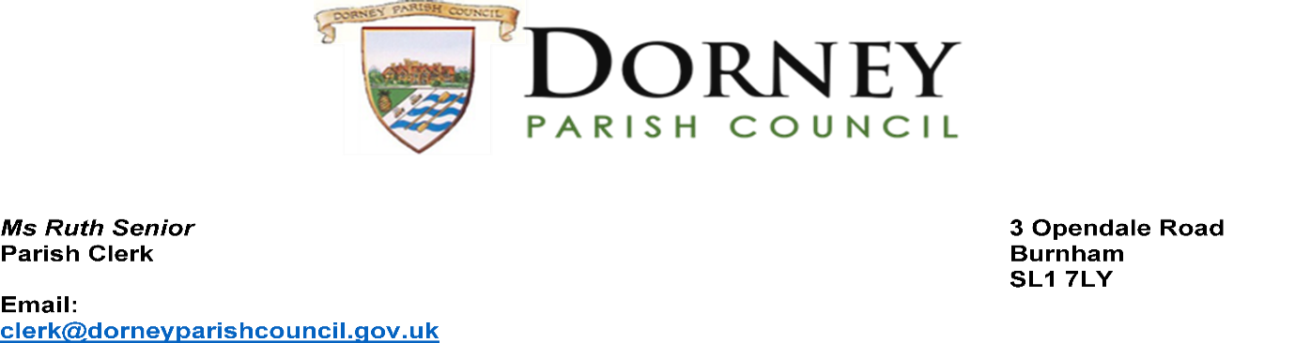
Planning Policy Team 28th July 2022
Buckinghamshire Council
Gateway House
Aylesbury
Bucks

Application for Designation of a Neighbourhood Area

Dorney Parish Council wish to apply for the designation of the Parish of Dorney as a Neighbourhood Area with the intention to develop a Neighbourhood Plan as defined by the Neighbourhood Planning (General) Regulations 2012.

Our application was approved at our last Parish Council meeting on 19th July 2022.
Dorney Parish Council is a relevant body as defined by the Town and Country Planning Act 1990 section 61G. The Neighbourhood Area is to incorporate the entire parish area (as shown in the map attached). Dorney Parish Council intend to keep the Planning Authority updated on the Neighbourhood Plan’s progression throughout its process.

Statement in Support of a Neighbourhood area
The Parish of Dorney is one community, although Dorney Reach and Boveney are separated from the village by a field owned by Thames Water and the ancient Common Land. Dorney village and Boveney were built from 1300s onwards, whilst Dorney Reach was built in the 1900s. The Parish Church is within the grounds of Dorney Manor and both were built in the 1300s. There is another church within Boveney hamlet. The Parish has two schools, two public houses, and a village hall.
The 2012 Olympic rowing lake runs between Dorney Village and Boveney. Dorney Reach has a very active community group including activities for younger and older children.
Dorney Parish is surrounded by the green belt. It is within a conservation area and has a number grade 1 and 2 listed buildings.

The Parish provides essential services for its residents including recreation areas with
equipment/apparatus, verge maintenance, some street lighting maintenance, a defibrillator and emergency plan for unforeseen weather conditions.

Buckinghamshire is now the Unitary Authority and with the withdrawal of the emerging Chiltern and South Bucks local plan in October 2020, Dorney Parish Council believes it is in the best interest of the

Dorney community that the Parish is designated as a Neighbourhood Area in order to work with residents to develop a plan that best suites its existing and future demographic needs of the Parish.

Kind Regards,

R Senior
Ruth Senior – Dorney Parish Clerk

